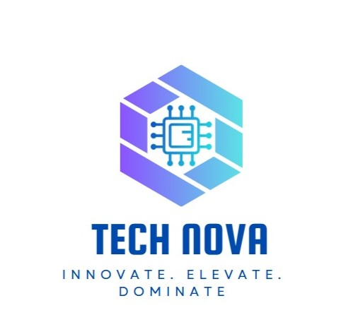

# Employee Engagement Template

# Employee Information

What is your job role?

Individual Contributor

Team Lead

Manager

Senior Manager

Regional Manager

Vice President

Management / C-Level

Partner

Owner

Volunteer

Intern

Other

What department do you work in?

Finance

IT

Human Resources

Operations

Testing

CRM

ERD

Customer Service

Did you feel a sense of belonging within the team and organization?

No. My ideas were not welcomed and there was a lack of mutual respect.

How would you rate the work environment and culture?

Unhealthy. Limited collaboration and expression due to manager control.

How would you describe the effectiveness of your immediate supervisor?

Poor. The manager restricts development and refuses to consider team input.

Were your goals and expectations aligned with the organization’s vision?

Yes, but I couldn’t contribute meaningfully due to lack of freedom and support.

Did you find the company’s policies and procedures fair and equitable?

No. Favoritism exists, and promotion decisions are not transparent.

How would you rate the organization’s support for maintaining a healthy work-life balance?

Not supportive. Long hours and no remote work options.

Were you satisfied with your salary and benefits package?

No. Below market standards and no benefits like health insurance.

Did you receive enough training and development opportunities?

No. No technical or leadership development programs are available.

Did you experience burnout or excessive stress in your role?

Yes. Due to micromanagement and lack of appreciation.

Would you recommend this company as a good place to work?

No. The environment is demotivating and unproductive.

Do you find your daily tasks engaging and meaningful?

No. Repetitive tasks with no opportunity to innovate or grow.

Do you feel recognized for your contributions and efforts?

No. There’s no feedback or reward system.

Do you feel challenged in your role in a positive way?

No. Tasks are restrictive and not aligned with my potential.

How would you rate the overall work environment in the IT department?

Poor. The environment is rigid, unsupportive, and lacking collaboration. Employees feel micromanaged, undervalued, and limited in their potential. There’s a strong need for leadership reform and cultural change to improve morale and productivity.

How comfortable do you feel reaching out for help when facing technical challenges?

Not comfortable. The manager discourages open discussion and sharing of ideas, which creates a culture of fear rather than support. Employees hesitate to seek help, fearing criticism or being ignored, which negatively affects performance and morale.

Have you received sufficient training and development opportunities in the last year?

No. The IT department has not received adequate training. There is no structured development program in place, and employee growth is not prioritized. The lack of investment in skill-building leaves team members stagnant and disengaged.

How would you describe your current workload?

The workload is heavy and poorly distributed, often assigned without clear priorities. Due to lack of managerial support and rigid oversight, employees feel overworked and underutilized, with little time for innovation or professional development.

What improvements would you suggest to enhance employee engagement and job satisfaction?

• Implement a clear and fair promotion policy to ensure equal growth opportunities.

• Provide consistent training and upskilling programs, especially in technical and leadership areas.

• Introduce a hybrid work policy to support work-life balance.

• Create a safe space for idea sharing and feedback, without fear of judgment.

• Train managers on people management and teamengagement to shift from control to collaboration.

Is leadership invested in and contributing to your culture initiatives?

No. Leadership is **not involved or interested** in building a positive culture. There’s a noticeable gap between management and employees, and no visible effort is made to improve engagement, inclusivity, or team morale.

Do you see yourself working here in a year?

No. Given the current environment **— lack of growth, poor leadership, and minimal support —** it is unlikely I would stay unless significant changes are made.

Does your work challenge you and aid your development?

No. Work tasks are often **repetitive and controlled**, leaving no room for innovation or skill expansion. The manager’s restrictive approach limits growth opportunities.

Do you have the tools needed to maximize your potential here?

No. Many systems and tools are outdated or inefficient, and employees are not empowered with resources that would help them succeed.

What motivates you to do your best work here?

Primarily, **personal ambition and internal drive**. The current company culture does not provide external motivation through appreciation, rewards, or growth opportunities

What could we do better to support your career growth and development?

* Establish a structured training and development program.
* Provide access to modern tools and resources.
* Empower managers with leadership training to encourage collaboration.
* Implement a clear promotion and recognition system.
* Foster a culture of trust and idea-sharing within the team.